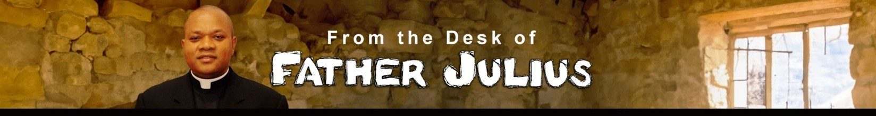
Brothers and Sisters in Christ; Grace and Peace!
As we continue to listen to the teachings of our Lord during Ordinary Time, our liturgies this weekend are centered on the Christians' call to be the salt and the light of the world. Jesus wants His disciples to understand that they are not Christians for themselves alone but are called to shine for others to see and to be an influence in the world. Therefore, He reminds His disciples to be a light that shines brightly for all to see, reflecting the light of Christ Himself and to be salt, an element that improves and preserves things and changes them for the better.

In our First Reading, the prophet Isaiah gives us a practical approach to how our light can shine for others to see: “Share your bread with the hungry, shelter the homeless, and clothe the naked.” These are what the Church calls the corporal works of mercy. They are considered, even by the United Nations, as fundamental human rights. They are the basic necessities of life. Their deprivation robs humanity of dignity and leaves people in perpetual darkness. This is what the Christian is called to address. That is why, at our baptism, one of the symbols we are given is a lighted candle. Following this same teaching, Saint Paul testified that he was a “light” to the early Christians in Corinth. His words and his presence illuminated the Christian community. Also, as “salt,” he helped in preserving their faith and salvation. He did this not only through his words, but also through his actions. In effect, Saint Paul wants the Corinthians to experience the "power of God" through his ministry.

Our Lord, in the Gospel, emphasized the significance of salt as it applies to His disciples. In the Old Testament, salt was used to season sacrificial offerings for sin and in celebration of God's covenant with them: “Season all your grain offerings with salt; you shall not let the salt of the covenant with your God be lacking from your cereal offering” (Lev 2:13).
Land agreements were also sealed with a gift of salt as proof of the strength and permanence of the contract. Salt was further seen as a symbol of God’s activity in a person’s life because it penetrates, preserves, and aids in healing. In the same way, our Lord expects Christians to be salt, salt that changes things for the better.

It may be a delicate question, but it is a necessary one: What does my lifestyle say about me? Am I light? Am I salt? Does what I say and do influence others for good or for harm? As a Christian, am I living in fidelity to Christ and His ways? We must not forget that the law of Christ is more important than any other regulation, even Church laws is to love God and our neighbor as ourselves. As Saint John reminds us, we cannot love God unless we love our neighbor.

Once again, let us realize that we were not baptized for ourselves alone, rather we were baptized into Christ and into the missionary activity of the Church. Whatever call or vocation we have been gifted with, our lives should speak of Christ, especially through our love for God and one another, expressed in forgiveness, tolerance, the avoidance of rash judgment, and respect for the good name of others. In this way, let our lives speak of God’s love. Be light! Be salt! Let God's power break forth in you!

A Blessed Sunday!

