Call the office to donate for the Sanctuary Lamp or for Altar Flowers, for a loved one or in memory of a loved one.
  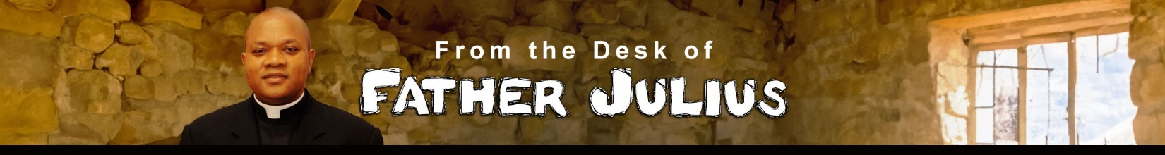
  Brothers and Sisters in Christ; Grace and Peace!
  In the liturgy of this Sunday, the Church places before us our goal as Christians, true and lasting happiness—and shows us the attitudes and actions necessary to attain it. These attitudes are beautifully summarized in the Beatitudes, which form the foundation of Christ-like living. They outline the personal qualities expected of every disciple and point us toward the way of life we are called to embrace as Christians. Among these virtues, one stands out as particularly challenging and essential: humility.
  In the First Reading, the prophet Zephaniah speaks during a time of great distress, destruction, and profound suffering in Israel. Yet in the midst of this darkness, he proclaims a blessing upon a “moral minority” among the people of Israel. These are those who seek justice, humility, truth, and righteousness. Their blessedness comes from their total dependence on God. They do not rely on power, wealth, or status, but place their trust in the Lord alone. In the same vein, St. Paul reminds the Corinthians and us, not to boast in ourselves. He urges believers to recognize that all they possess is a gift from God, meant to serve the good of the community. God chose what the world considers foolish, weak, and lowly, and through Christ has justified, sanctified, and redeemed us. Since everything we have is grace, there is nothing to boast about except the Lord. It is precisely this free and unmerited gift that reveals the true wisdom and power of God.
  In today’s Gospel, Jesus presents us with the Beatitudes, one of the most radical teachings in all of Scripture. He speaks of the paradoxical blessedness of poverty, hunger, sorrow, and persecution. In poverty, we discover God’s reign. In hunger, we experience His providence. In sorrow, we find true happiness. In persecution, we encounter authentic joy. The blessed are those who are poor in spirit, meek, merciful, clean of heart, compassionate, peacemakers, and those willing to endure insult and persecution for the sake of their faith in Christ. Zephaniah, Paul, and Matthew each invite us to make a humble confession:
  without God, we are nothing. Yet with His grace at work in us, we are capable of living holy, joyful, and meaningful lives.
  This truth becomes especially clear when we look at our own society. Despite the abundance of wealth and material comfort in the United States, many people struggle deeply with despair. In 2023, nearly 50,000 people died by suicide, one of the highest levels in decades. These sobering numbers remind us that material success alone cannot bring happiness. There is more to life than possessions, achievements, or comfort. True happiness is found only in God, who is the ultimate source and fulfillment of human life. The Beatitudes challenge us to live differently. They call us to stand with the poor, to comfort those who mourn, to practice meekness, and to hunger and thirst for justice. They invite us to be compassionate, pure of heart, and peacemakers in our families, our communities, and our world—even when this way of life brings misunderstanding, ridicule, or persecution.
  Each time we reach out to the needy, the sick, and the oppressed, we offer them a glimpse of the promises of the Beatitudes here and now. In doing so, we walk the path Christ has laid before us, a path that leads not to fleeting happiness, but to eternal joy. Where do you think you are today on the path Christ has laid out for you?
  May the Lord grant us the grace to live the Beatitudes each day.
  Have a blessed Sunday.
  This Week’s Readings and Mass Intentions
    Mon., Feb 2: Mal 3: 1-4, Heb 2: 14-18, Lk 2: 22-40 or Lk 2: 22-32
    9:00 a.m. - No Mass
    Tue., Feb 3: 2 Sm 18: 9-10, 14, 24-25a, 30 – 19: 3, Mk 5: 21-43
    9:00 a.m. Mass - Carol Hatch by The Fusaro’s Family
    Wed., Feb 4: 2 Sm 24: 2, 9-17, Mk 6: 1-6
    9:00 a.m. Mass - Carol Hatch by The Fusaro’s Family
    Thu. Feb 5: 1Kgs 2: 1-4, 10-12, Mk 6: 7-13
    9:00 a.m. Mass - Marty Simmering by Jessie Fusaro
    Fri., Feb 6: Sir 47: 2-11, Mk 6: 14-29
    9:00 a.m. Mass – Lauren Stark (Birthday) by Chris & Chris Cotler
    Sat., Feb 7: 1Kgs 3: 4-13, Mk 6: 30-34
    4:00 p.m. Mass - Michael Dougherty by The Parish Family
    Sun., Feb 8: Is 58: 7-10, 1 Cor 2: 1-5, Mt 5: 13-16
    8:00 a.m. Mass - Thomas Spence by Don & Claudia Brazeau
    10:00 a.m. Mass – Larry Ford (Health & Healing) by Ralph Arata
    12:30 p.m. Mass – People of the Parish
  This week, the Sanctuary Lamp burns in memory of Carol Hatch by The Fusaro’s Family.
  No Altar Flowers donated this week.
  Here is a headline in case you want to insert some content here
  Lorem ipsum dolor sit amet, consectetur adipiscing elit, sed do eiusmod tempor incididunt ut labore et dolore magna aliqua. Ut enim ad minim veniam. | Lorem ipsum dolor sit amet, consectetur adipiscing elit, sed do eiusmod tempor incididunt ut labore et dolore magna aliqua. Ut enim ad minim veniam.
  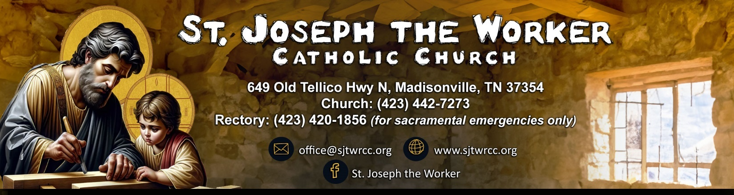
  January 31, 2026, | The Fouth Sunday in Ordinary Time  Pastoral Staff  Pastor……………………..................………………….Rev. Dr. Julius Abuh  ………………………………………….….…frjabuh@gmail.com (personal)  Deacon …………………………………………………………...Walter Stone  wjstone01@outlook.com  Parish Secretary/Bookkeeper……………….…...………Claudia Brazeau  …………………………………………….….……….…….office@sjtwrcc.org  Office Assistant………………………….…….…….………..Jessie Fusaro  …………………………………………….….…..…….assistant@sjtwrcc.org  Operations Manager………………………………….……….Mary Beavers  ………………………………………………………………gee4949@aol.com  Hispanic Ministry………………………….…..…...Maria Leon/Joel Garcia  Director, Religious Education………...……………………..Tami Clowers  Order of Christian Initiation of Adults (OCIA).…………...Ben Swiderek  Coordinator of Youth Ministry………………………..….Daniela Aguilera  Director of Sacred Music…………………………………….Jodi Swiderek  Knights of Columbus……………………………..….…….Gerry Schlueter  Women’s Group…………………….……………...........……….Tina Bolton  Sacramental Needs | Mass Schedule  Saturday: 4:00 p.m.  Sunday: 8:00 a.m.,10:00 a.m. and 12:30 p.m. (Spanish)  Weekdays: 9:00 a.m. – Tuesday- Friday  Adoration  Friday: 9:30 a.m. – 12:00 p.m.  Rosary  Wednesday: 9:30 a.m. (after Mass)  Thursday: 7:00 p.m. (in the Grotto)    Inspiration from St. John Bosco’s Dedication  Lord Jesus, we thank You for the Inspiring dedication of  John Bosco, who devoted his life to the youth and the marginalized.  May his unwavering faith and commitment ignite in us a passion for service and compassion.  Help us to follow his example, nurturing hope and joy in the hearts of those we encounter.  Amen.
     | Baptism: Preparation is required for parents who desire their child to be baptized. Parents must be registered with the church. Forms are available in the office.
     | Reconciliation: Offered on Saturdays at 3:15 p.m., Sundays at 9:15 a.m. and 12 p.m. (Spanish) or upon request.
     | Pastoral Care of the Sick: Notify the office for homebound or hospitalized to request a visit from Father Julius for either communion or anointing of the sick. In the event of death, Mass can be offered immediately or on a date convenient for the family.
     | Holy Matrimony: Couples should contact the pastor a minimum of six months in advance. Dates may not be set prior to the second meeting with the priest. The Diocese requires couples to attend an Engaged Encounter of Picture of Love Weekend.
    Stay connected and discover more about our parish life  at www.sjtwrcc.org. Find Mass times, events, ministries,  bulletins, and more! |  | 

