This week, the Sanctuary Lamp burns in memory of Patrick Fusaro by The Fusaro’s Family.  No Altar Flowers donated this week  Call the office to donate for the Sanctuary Lamp or for Altar Flowers, for a loved one or in memory of a loved one.
  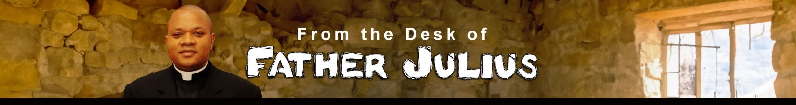
  Brothers and Sisters in Christ; Grace and Peace!
  As we continue to listen to the teachings of our Lord during Ordinary Time, our liturgies this weekend are centered on the Christians' call to be the salt and the light of the world. Jesus wants His disciples to understand that they are not Christians for themselves alone but are called to shine for others to see and to be an influence in the world. Therefore, He reminds His disciples to be a light that shines brightly for all to see, reflecting the light of Christ Himself and to be salt, an element that improves and preserves things and changes them for the better.
  In our First Reading, the prophet Isaiah gives us a practical approach to how our light can shine for others to see: “Share your bread with the hungry, shelter the homeless, and clothe the naked.” These are what the Church calls the corporal works of mercy. They are considered, even by the United Nations, as fundamental human rights. They are the basic necessities of life. Their deprivation robs humanity of dignity and leaves people in perpetual darkness. This is what the Christian is called to address. That is why, at our baptism, one of the symbols we are given is a lighted candle. Following this same teaching, Saint Paul testified that he was a “light” to the early Christians in Corinth. His words and his presence illuminated the Christian community. Also, as “salt,” he helped in preserving their faith and salvation. He did this not only through his words, but also through his actions. In effect, Saint Paul wants the Corinthians to experience the "power of God" through his ministry.
  Our Lord, in the Gospel, emphasized the significance of salt as it applies to His disciples. In the Old Testament, salt was used to season sacrificial offerings for sin and in celebration of God's covenant with them: “Season all your grain offerings with salt; you shall not let the salt of the covenant with your God be lacking from your cereal offering” (Lev 2:13).
  Land agreements were also sealed with a gift of salt as proof of the strength and permanence of the contract. Salt was further seen as a symbol of God’s activity in a person’s life because it penetrates, preserves, and aids in healing. In the same way, our Lord expects Christians to be salt, salt that changes things for the better.
  It may be a delicate question, but it is a necessary one: What does my lifestyle say about me? Am I light? Am I salt? Does what I say and do influence others for good or for harm? As a Christian, am I living in fidelity to Christ and His ways? We must not forget that the law of Christ is more important than any other regulation, even Church laws is to love God and our neighbor as ourselves. As Saint John reminds us, we cannot love God unless we love our neighbor.
  Once again, let us realize that we were not baptized for ourselves alone, rather we were baptized into Christ and into the missionary activity of the Church. Whatever call or vocation we have been gifted with, our lives should speak of Christ, especially through our love for God and one another, expressed in forgiveness, tolerance, the avoidance of rash judgment, and respect for the good name of others. In this way, let our lives speak of God’s love. Be light! Be salt! Let God's power break forth in you!
  A Blessed Sunday!
  This Week’s Readings and Mass Intentions
    Mon., Feb 9: 1Kgs 8: 1-7, 9-13, Mk 6: 53-56
    9:00 a.m. – No Mass - Diocesan Priest Study Week
    Tue., Feb 10: 1Kgs 8: 22-23, 27-30, Mk 7: 1-13
    9:00 a.m. – No Mass (Communion Service Only)
    Wed., Feb 11: 1Kgs 10: 1-10, Mk 7: 14-23
    9:00 a.m. - No Mass (Communion Service Only)
    Thu. Feb 12: 1Kgs 11: 4-13, Mk 7: 24-30
    9:00 a.m. Mass – Archbishop John Bonaventure Kwofie (Intentions) by ---
    Fri., Feb 13: 1Kgs 11: 29-32; 12: 19, Mk 7: 31-37
    9:00 a.m. Mass - Robert DeRegis by Don & Claudia Brazeau
    Sat., Feb 14: 1Kgs 12: 26-32; 13: 33-34, Mk 8: 1-10
    4:00 p.m. Mass - Paul R Griego by The Griego’s Family
    Sun., Feb 15: Sir 15: 15-20, 1 Cor 2: 6-10, Mt 5: 17-37
    8:00 a.m. Mass - Alan Beavers by The Beaver’s Family
    10:00 a.m. Mass - Martin E. Smith by Jean & Roger Schneider
    12:30 p.m. Mass – People of the Parish
  Here is a headline in case you want to insert some content here
  Lorem ipsum dolor sit amet, consectetur adipiscing elit, sed do eiusmod tempor incididunt ut labore et dolore magna aliqua. Ut enim ad minim veniam. | Lorem ipsum dolor sit amet, consectetur adipiscing elit, sed do eiusmod tempor incididunt ut labore et dolore magna aliqua. Ut enim ad minim veniam.
  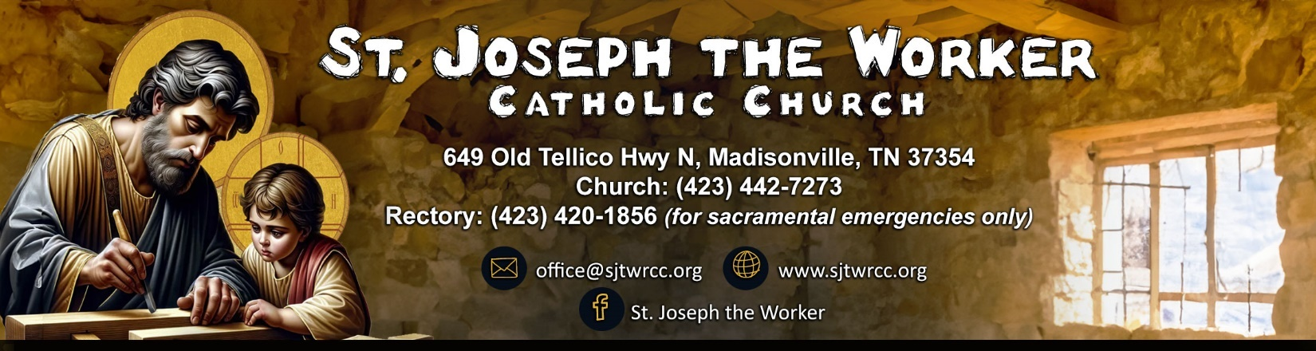
  February 7th, 2026, | The Fifth Sunday in Ordinary Time  Pastoral Staff  Pastor……………………..................………………….Rev. Dr. Julius Abuh  ………………………………………….….…frjabuh@gmail.com (personal)  Deacon …………………………………………………………...Walter Stone  wjstone01@outlook.com  Parish Secretary/Bookkeeper……………….…...………Claudia Brazeau  …………………………………………….….……….…….office@sjtwrcc.org  Office Assistant………………………….…….…….………..Jessie Fusaro  …………………………………………….….…..…….assistant@sjtwrcc.org  Operations Manager………………………………….……….Mary Beavers  ………………………………………………………………gee4949@aol.com  Hispanic Ministry………………………….…..…...Maria Leon/Joel Garcia  Director, Religious Education………...……………………..Tami Clowers  Order of Christian Initiation of Adults (OCIA).…………...Ben Swiderek  Coordinator of Youth Ministry………………………..….Daniela Aguilera  Director of Sacred Music…………………………………….Jodi Swiderek  Knights of Columbus……………………………..….…….Gerry Schlueter  Women’s Group…………………….……………...........……….Tina Bolton  Sacramental Needs | Mass Schedule  Saturday: 4:00 p.m.  Sunday: 8:00 a.m.,10:00 a.m. and 12:30 p.m. (Spanish)  Weekdays: 9:00 a.m. – Tuesday- Friday  Adoration  Friday: 9:30 a.m. – 12:00 p.m.  Rosary  Wednesday: 9:30 a.m. (after Mass)  Thursday: 7:00 p.m. (in the Grotto)    Inspiration from St. John Bosco’s Dedication  Lord Jesus, we thank You for the Inspiring dedication of  John Bosco, who devoted his life to the youth and the marginalized.  May his unwavering faith and commitment ignite in us a passion for service and compassion.  Help us to follow his example, nurturing hope and joy in the hearts of those we encounter.  Amen.
     | Baptism: Preparation is required for parents who desire their child to be baptized. Parents must be registered with the church. Forms are available in the office.
     | Reconciliation: Offered on Saturdays at 3:15 p.m., Sundays at 9:15 a.m. and 12 p.m. (Spanish) or upon request.
     | Pastoral Care of the Sick: Notify the office for homebound or hospitalized to request a visit from Father Julius for either communion or anointing of the sick. In the event of death, Mass can be offered immediately or on a date convenient for the family.
     | Holy Matrimony: Couples should contact the pastor a minimum of six months in advance. Dates may not be set prior to the second meeting with the priest. The Diocese requires couples to attend an Engaged Encounter of Picture of Love Weekend.
    Stay connected and discover more about our parish life  at www.sjtwrcc.org. Find Mass times, events, ministries,  bulletins, and more! |  | 

